GARY BRAZIL

CA2

Machine Learning for Business

Data Visualisation

GitHub Link: https://github.com/GaryBraz/GB-ML-DV-Assignment
Report word count: 2186

Question 1

Time Series Analysis of Air Passenger Data

Introduction
This report provides a detailed analysis of a time series dataset representing air passenger numbers. I looked at a number of datasets on the likes of Kaggle before I decided to use this particular dataset. I used statistical methods and machine learning models to forecast future trends and understand the underlying patterns in the dataset. Key steps in this analysis include data loading and preprocessing, stationarity testing, model selection and fitting, forecasting, and error analysis.
Argument
The analysis began with loading the air passenger dataset. Initial exploration of the data involved understanding its structure and distribution.
AUGMENTED DICKEY-FULLER TEST(ADF)
A critical component of time series analysis is stationarity testing, which was performed using the Augmented Dickey-Fuller test (Figure 1). Augmented Dickey Fuller test (ADF Test) is a common statistical test used to test whether a given Time series is stationary or not. It is one of the most commonly used statistical test when it comes to analyzing the stationary of a series. This test is vital to determine if the data is suitable for time series modeling without needing differencing or transformations.
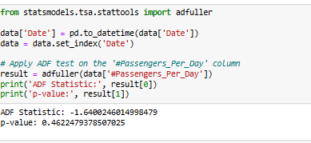
Figure 1: Results of Augmented Dickey-Fuller Test
The original data's Augmented Dickey-Fuller test yielded an ADF Statistic of -1.64 and a p-value of 0.46, suggesting non-stationarity.
STATIONARY CHECK
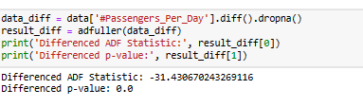
Figure 2: Results of ADF Test after differencing the data
Post differencing (Figure 2), the ADF Statistic improved to -31.43 with a p-value of 0.0, indicating achieved stationarity. The process of differencing has effectively removed trends or seasonality that might have been present in the original data, making it suitable for further analysis or modelling.
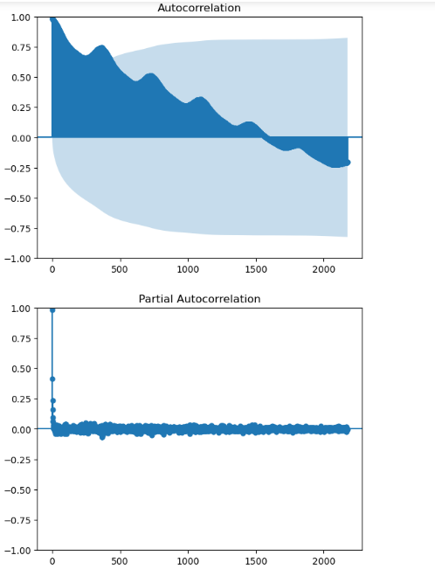
Figure 3: Autocorrelation results
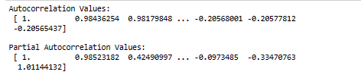
Autocorrelation measures how a time series relates to its past, with values near 1 or -1 indicating strong links. The first value is 1, showing self-correlation. Subsequent values, like 0.98, indicate correlation with previous points. Partial autocorrelation, however, focuses on specific lag connections, aiding in ARIMA model selection and revealing trends or seasonality in data.
ARIMA MODEL
After confirming stationarity, I selected the ARIMA model, a widely-used method for forecasting time series data, particularly with non-stationary data. Model parameters were chosen based on Autocorrelation and Partial Autocorrelation Functions analysis.
Model Summaries

ARIMA(1, 1, 1) Model Summary
SARIMAX Results
===============================================================================
Dep. Variable: #Passengers_Per_Day No. Observations: 4353
Model: ARIMA(1, 1, 1) Log Likelihood -3810.944
Date: Sun, 19 Nov 2023 AIC 7627.888
Time: 17:39:54 BIC 7647.023
Sample: 01-31-1949 HQIC 7634.642
- 12-31-1960
Covariance Type: opg
==============================================================================
coef std err z P>|z| [0.025 0.975]
------------------------------------------------------------------------------
ar.L1 0.0809 0.009 8.885 0.000 0.063 0.099
ma.L1 -0.6975 0.007 -93.023 0.000 -0.712 -0.683
sigma2 0.3373 0.002 204.536 0.000 0.334 0.341
===================================================================================
Ljung-Box (L1) (Q): 0.01 Jarque-Bera (JB): 281111.57
Prob(Q): 0.94 Prob(JB): 0.00
Heteroskedasticity (H): 3.09 Skew: 2.53
Prob(H) (two-sided): 0.00 Kurtosis: 42.05
===================================================================================

ARIMA(1, 1, 2) Model Summary
SARIMAX Results
===============================================================================
Dep. Variable: #Passengers_Per_Day No. Observations: 4353
Model: ARIMA(1, 1, 2) Log Likelihood -3810.347
Date: Sun, 19 Nov 2023 AIC 7628.693
Time: 17:39:57 BIC 7654.207
Sample: 01-31-1949 HQIC 7637.699
- 12-31-1960
Covariance Type: opg
==============================================================================
coef std err z P>|z| [0.025 0.975]
------------------------------------------------------------------------------
ar.L1 0.3758 0.132 2.854 0.004 0.118 0.634
ma.L1 -0.9934 0.133 -7.452 0.000 -1.255 -0.732
ma.L2 0.1943 0.086 2.252 0.024 0.025 0.363
sigma2 0.3372 0.002 196.493 0.000 0.334 0.341
===================================================================================
Ljung-Box (L1) (Q): 0.00 Jarque-Bera (JB): 280483.34
Prob(Q): 0.99 Prob(JB): 0.00
Heteroskedasticity (H): 3.09 Skew: 2.52
Prob(H) (two-sided): 0.00 Kurtosis: 42.00
===================================================================================

ARIMA(2, 1, 1) Model Summary
SARIMAX Results
===============================================================================
Dep. Variable: #Passengers_Per_Day No. Observations: 4353
Model: ARIMA(2, 1, 1) Log Likelihood -3810.403
Date: Sun, 19 Nov 2023 AIC 7628.807
Time: 17:39:57 BIC 7654.320
Sample: 01-31-1949 HQIC 7637.812
- 12-31-1960
Covariance Type: opg
==============================================================================
coef std err z P>|z| [0.025 0.975]
------------------------------------------------------------------------------
ar.L1 0.0978 0.015 6.718 0.000 0.069 0.126
ar.L2 0.0227 0.011 2.014 0.044 0.001 0.045
ma.L1 -0.7153 0.015 -48.652 0.000 -0.744 -0.687
sigma2 0.3373 0.002 199.751 0.000 0.334 0.341
===================================================================================
Ljung-Box (L1) (Q): 0.00 Jarque-Bera (JB): 280849.34
Prob(Q): 0.99 Prob(JB): 0.00
Heteroskedasticity (H): 3.09 Skew: 2.52
Prob(H) (two-sided): 0.00 Kurtosis: 42.03
===================================================================================

ARIMA(2, 1, 2) Model Summary
SARIMAX Results
===============================================================================
Dep. Variable: #Passengers_Per_Day No. Observations: 4353
Model: ARIMA(2, 1, 2) Log Likelihood -3810.492
Date: Sun, 19 Nov 2023 AIC 7630.984
Time: 17:39:58 BIC 7662.876
Sample: 01-31-1949 HQIC 7642.240
- 12-31-1960
Covariance Type: opg
==============================================================================
coef std err z P>|z| [0.025 0.975]
------------------------------------------------------------------------------
ar.L1 -0.3005 0.717 -0.419 0.675 -1.705 1.104
ar.L2 0.0512 0.055 0.931 0.352 -0.057 0.159
ma.L1 -0.3168 0.717 -0.442 0.659 -1.722 1.088
ma.L2 -0.2761 0.496 -0.557 0.578 -1.248 0.696
sigma2 0.3373 0.002 199.867 0.000 0.334 0.341
===================================================================================
Ljung-Box (L1) (Q): 0.00 Jarque-Bera (JB): 281138.36
Prob(Q): 0.98 Prob(JB): 0.00
Heteroskedasticity (H): 3.09 Skew: 2.53
Prob(H) (two-sided): 0.00 Kurtosis: 42.05
===================================================================================

The ARIMA(1, 1, 1) model, applied to 4,353 data points, effectively balances past trends and errors for forecasting. It merges slight positive influence from recent values with more substantial negative influence from past errors. Its strong performance (log likelihood: -3810.944, significant coefficients) and tests confirm its effectiveness in forecasting, as indicated by its performance metrics (AIC: 7627.888, BIC: 7647.023).
Autocorrelation Values of Residuals
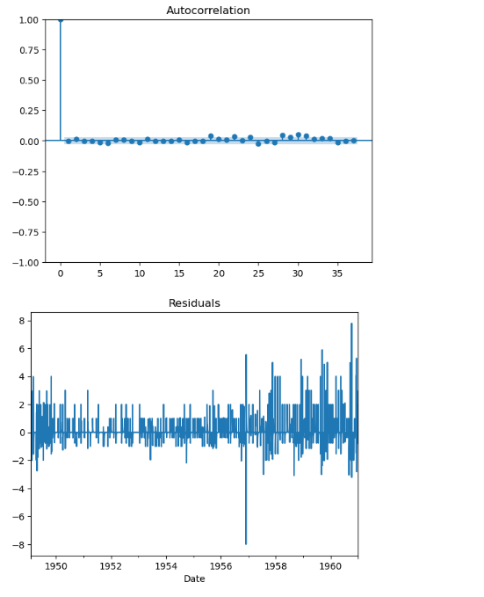
Figure 4: Autocorrelation values of Residuals
Interpretation
- Residual Values: Residuals are the differences between model predictions and actual data. For an effective model, these should be small, close to zero, and random, indicating the model's accuracy. The significance of residuals, ranging between 4.00 and -1.00, depends on the data's scale.
- Autocorrelation of Residuals: This measures the relationship between residuals over time. In this model, autocorrelation is very weak (values like -0.0038 and 0.012), which is ideal. Values near zero suggest no specific pattern in the residuals, indicating the model accurately captures the data's trends and patterns.
Forecasting
I fitted the ARIMA model to the data for short-term forecasting, aiming to predict the next 10 points in the time series. This approach is useful for immediate planning and decision-making. The model's forecasts, predicting values around 15.03 to 15.19 for several months, indicated a stable trend without significant changes, suggesting consistency in the pattern without major shifts or seasonal variations.

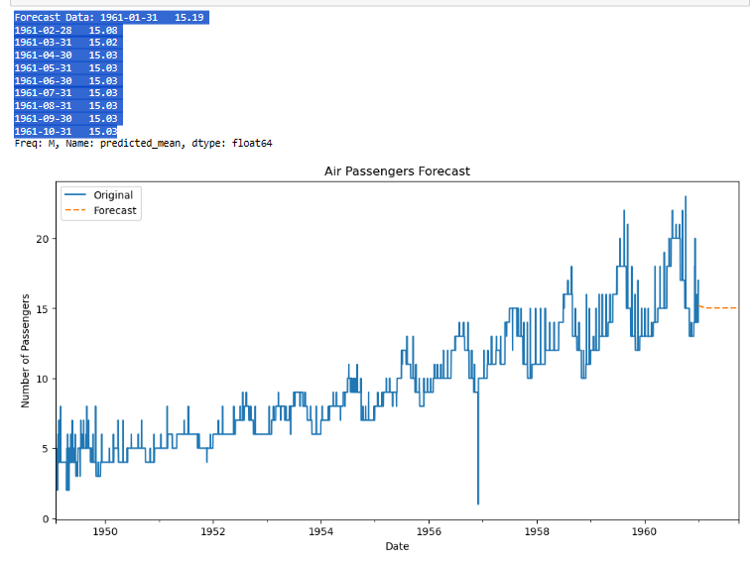
Figure 5: Graph showing Original and Forecasted results of data
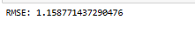
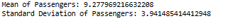
The model’s accuracy was evaluated using the Root Mean Squared Error (RMSE) of 1.16, compared to the data's average (9.28) and standard deviation (3.94). The RMSE being smaller than these figures suggests the model's predictions are generally reliable, with errors smaller than the data's average fluctuation, indicating a good fit.
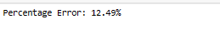
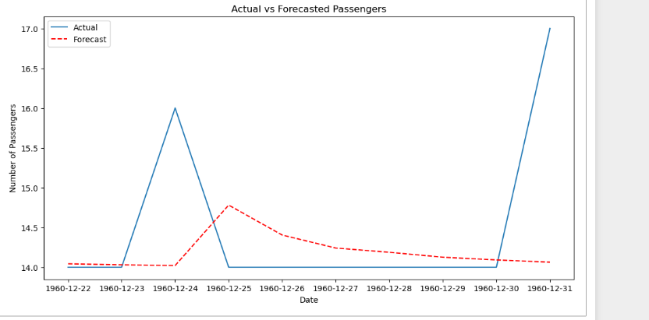
Figure 6: Actual vs Forecasted Passengers error results.
However, the analysis also considered the percentage error (12.49%), which provides a different perspective. This rate might be considered high in scenarios requiring precise predictions, like capacity planning. While the RMSE indicates a strong model fit, the percentage error, significant relative to actual values, reveals a nuanced view of the model's accuracy. The acceptability of this error rate depends on the model's intended use and the nature of the data, underlining the importance of balancing accuracy with practical application.

CONCLUSION

The ARIMA model's analysis of air passenger data highlights its capability in managing time series with clear trends and seasonal changes. The study underscores the significance of thorough autocorrelation analysis and model fitting for precise forecasts, vital in sectors like transportation, finance, and economics, where accurate predictions are key.

Future Recommendations:

Exploring Other Models: Beyond ARIMA, examining models like SARIMA or machine learning methods could yield better insights or performance.

Long-term Forecasting: Assessing the model's proficiency in long-term forecasting is essential for strategic planning.

Data Enrichment: Enhancing the model with extra variables, like economic factors or related transportation data, could refine its predictive accuracy.

Regular Model Updates: Continuously updating the model with fresh data maintains its relevance and accuracy, adjusting to changes in travel patterns or external influences.

Broader Applications: Applying this approach to diverse time-sensitive datasets across industries can offer wider insights and prove the model's adaptability.

Question 2

Analyzing Social Media Posts Using Text Analytics and Machine Learning

Introduction
This report presents an in-depth analysis of a dataset comprising social media posts, particularly from the subreddit "irishpersonalfinance". The primary objective is to apply text analytics and machine learning techniques to gain insights into the prevalent topics and trends within these posts. The steps followed in this analysis include data collection using the Reddit API, preprocessing of text data, application of machine learning models for text categorization and topic modeling, and summarization of key findings.
Argument
The process of analyzing social media data is multifaceted, requiring a nuanced approach to extract meaningful insights. The initial step involves data collection, where the Reddit API, accessed via the `praw` Python library, was utilized to gather recent posts from the last 5 days from the "irishpersonalfinance" subreddit. I chose this as it is a forum I use a lot and I find it very useful for personal finance queries that I may have. I stored the data I collected into a dataframe (as seen in Figure 1).
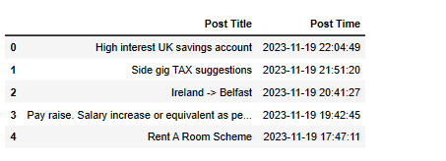
Figure 1 (Dataframe containing posts extracted from subreddit forum)
Subsequent to data collection, preprocessing of text data was undertaken. This crucial step involves cleaning and preparing the data for analysis, ensuring that the machine learning models can effectively process the text. Techniques such as tokenization, removal of stop words, and normalization were implied to refine the dataset.
The core of the analysis involved applying machine learning models for text categorization and topic modeling. Text categorization was performed using keyword-based methods, where posts were classified into different categories based on their content (as seen in Figure 2). This categorization helps in understanding the distribution of various topics and concerns among the subreddit's users.
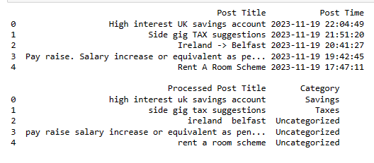
Figure 2 (Text categorization results)
The most significant part of the analysis involved topic modeling, executed using Latent Dirichlet Allocation (LDA). LDA is a powerful unsupervised machine learning technique that identifies latent topics within a large volume of text data. By applying LDA, the study aimed to uncover underlying themes and subjects prevalent in the subreddit posts, which might not be immediately apparent (See Figure 3). This model provides a comprehensive view of the primary interests and discussions among the subreddit's members.
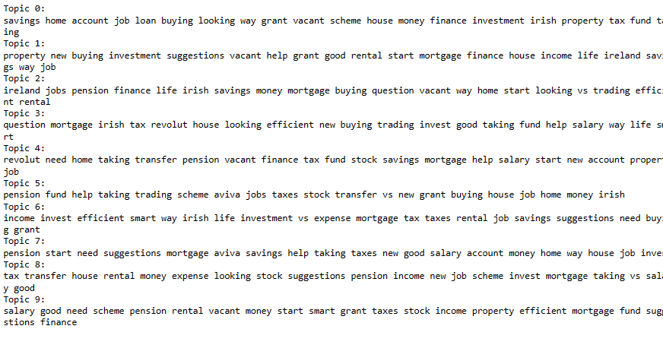
Figure 3 (LDA results)
Additionally, key phrase extraction was performed using TF-IDF (Term Frequency-Inverse Document Frequency) Vectorization (See Figure 4). This method identifies significant words or phrases within the text, contributing to the summarization of individual posts and aiding in highlighting the most pertinent information.
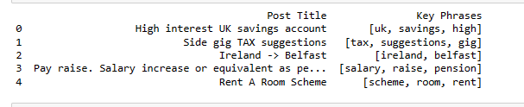 Figure 4 (TF-IDF results)

Conclusion

This report has demonstrated the significant capabilities of text analytics and machine learning in transforming raw, unstructured social media data into valuable insights. Through the use of the Reddit API, I obtained a dataset that is not only relevant but also reflective of real-world dynamics in online communities. The preprocessing of this data was a vital step, ensuring that the subsequent analysis was both accurate and meaningful.

The application of Latent Dirichlet Allocation (LDA) for topic modelling was particularly insightful. By extracting latent topics from the subreddit data, I gained a deep understanding of the primary concerns and interests that resonate within the community. This understanding is crucial, as it offers a window into the collective mindset, illuminating prevalent trends and patterns that might otherwise remain hidden in the complexity of unstructured text.

Moreover, the integration of text categorization and key phrase extraction techniques provided a finer, more detailed perspective. These methods, when used in conjunction with topic modelling, yielded a rich, multi-dimensional analysis of the text data. Such a comprehensive approach is instrumental in converting raw social media chatter into actionable intelligence.

The findings of this study highlight the significant impact of machine learning and text analytics in analyzing digital communication. The insights gained have diverse applications, from market research to community management. These advanced techniques are crucial in navigating the modern digital landscape, enabling effective interpretation and utilization of extensive online data for various practical and strategic purposes.

QUESTION 3

Creating Interactive Dashboards for Data Visualization

Introduction
This report provides an overview of the process and techniques used in creating an interactive dashboard for data visualization. The focus of this analysis was on a Sales dataset and how this data can be effectively represented through an interactive dashboard using technologies like Dash and Plotly. I began with data preparation to ensure that dataset was in the correct format for subsequent analytics. My initial focus was on isolating numerical data for correlation analysis in order to decipher the relationships between various sales metrics.

Argument
Recognizing the importance of planning and design in creating an effective dashboard, I also undertook the creation of a wireframe. This wireframe served as a blueprint for the dashboard, allowing me to visually conceptualize the layout and the placement of various elements. The purpose of this wireframe was multifaceted:
- Structure and Layout Planning: It helped me envision the overall structure of the dashboard, including how the different plots would be arranged and interact with each other.
- User Experience Consideration: By sketching out the dashboard, I could focus on the user experience, ensuring that the final product would be intuitive and user-friendly.
- Streamlining Development: The wireframe acted as a guide during the development process, streamlining my coding efforts and reducing the likelihood of major revisions later.
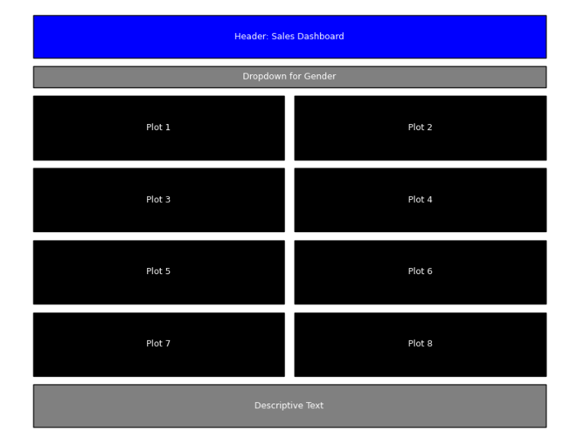
With the wireframe as a guiding tool, I progressed to the visualization phase, employing a variety of plots to represent the sales data effectively:
- I produced a heatmap to showcase the correlations among the numerical features, offering insights into the interdependencies within the sales variables.
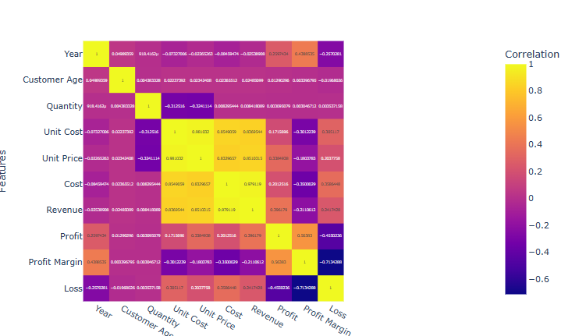
- I created a scatter plot to investigate the relationship between unit prices and revenue, a critical aspect of pricing strategy that could reveal the elasticity of demand in the face of pricing changes.
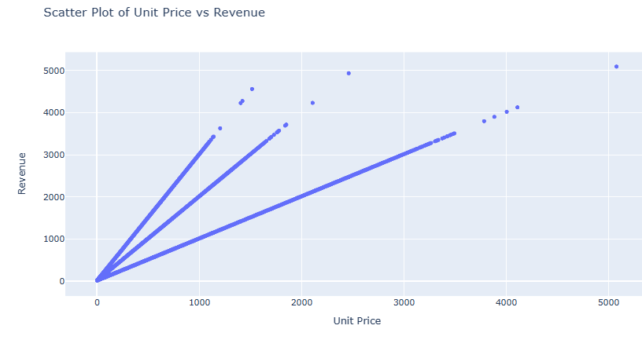
- I constructed a box plot to contrast revenue across customer genders. This visual element was aimed at surfacing demographic trends and preferences, potentially informing targeted marketing campaigns.
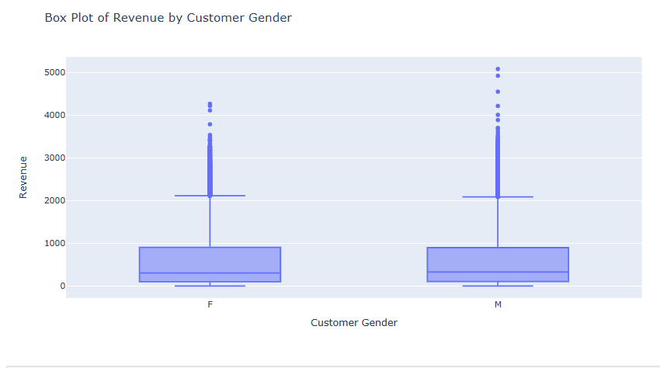
- I employed a histogram to display the distribution of customer ages, a chart that assists in understanding the age profile of the customer base and in tailoring the product offerings accordingly.
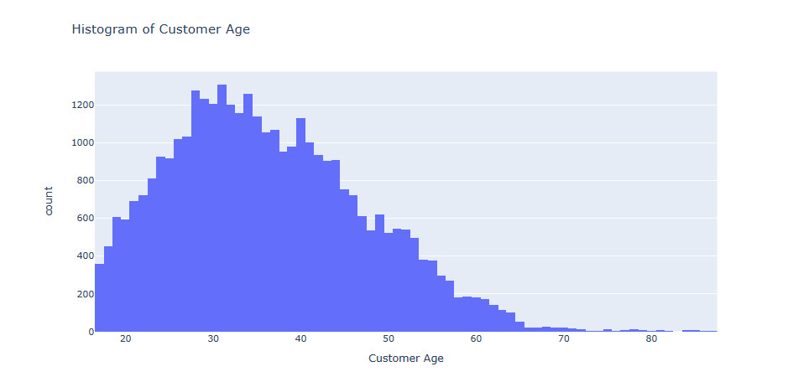
- I utilized a pie chart to delineate the sales distribution by country, a clear visual representation of market presence and an indicator of where to focus expansion strategies.
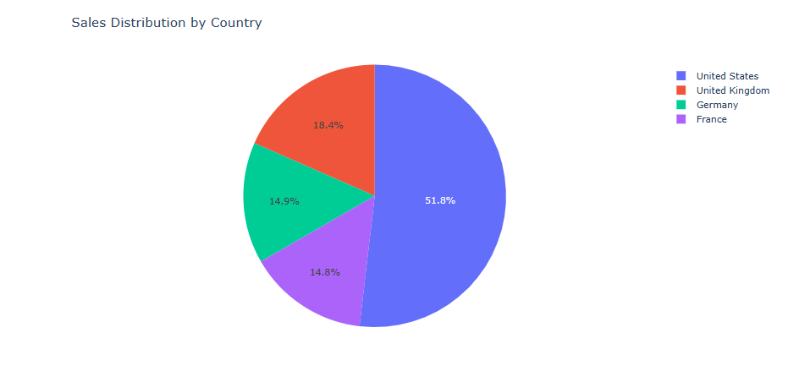
- I generated a bar chart to detail revenue by state, providing an at-a-glance view of regional sales performance and indicating where to concentrate sales efforts or investigate market underperformance.
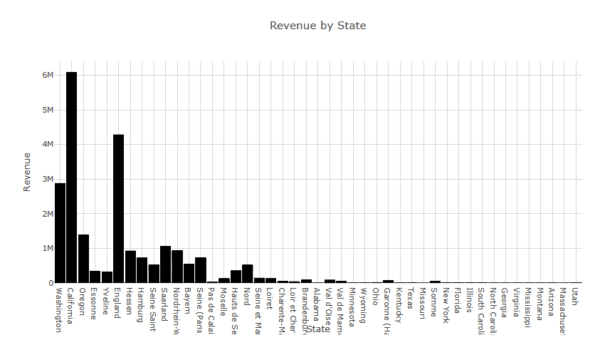
- I plotted a line chart to track revenue over time by product category. This plot is instrumental in discerning sales trends and the impact of temporal factors like seasonality or economic conditions on product performance.
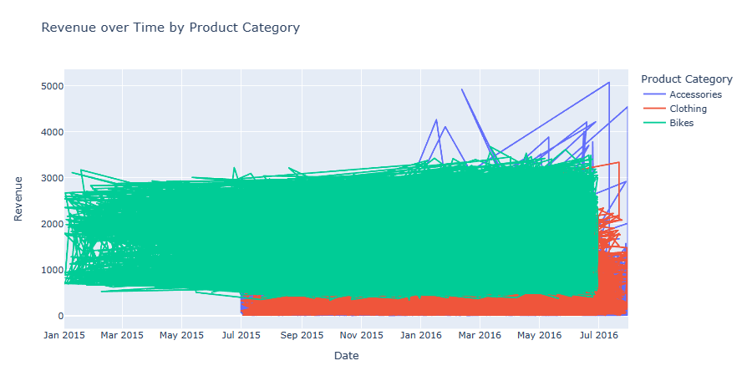
- I also included an additional bar chart that represented profit by age groups, offering a window into which demographics are most profitable and may warrant additional attention.
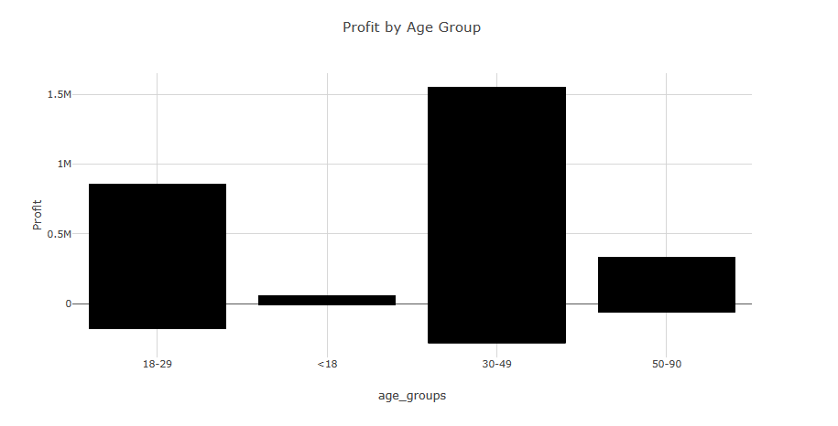
After crafting the visualizations, I began to assemble the Dash application. I laid out the application using html.Div elements, embedding the previously created plots within dcc.Graph components. The choice of a dark blue background and white text was deliberate, designed to ensure both aesthetic appeal and readability.
To add interactivity, I introduced a dropdown menu that allows for dynamic filtering of the box plot according to customer gender. This was achieved through a Dash callback, illustrating the dashboard's interactive capabilities.

Conclusions
The development of an interactive dashboard as detailed in the notebook showcases the potential of combining data analysis with web development tools. Dash and Plotly emerge as effective solutions for creating interactive and insightful visualizations. These tools bridge the gap between data analysis and user experience, providing an accessible way for end-users to engage with complex datasets.
In conclusion, this report underscores the importance of interactive dashboards in the realm of data visualization. It highlights the need for a well-structured approach to data handling and visualization, and the significant role of modern web-based tools in achieving this. The dashboard created in the notebook serves as an example of how data can be transformed into a dynamic and informative tool for business insights, decision making, and storytelling.

References

Selva Prabhakaran. (2022, November 2). Augmented Dickey Fuller Test (ADF Test) – Must Read Guide. Available at: https://www.machinelearningplus.com/time-series/augmented-dickey-fuller-test/?utm_content=cmp-true
Tim Smith (2023, March 19) Autocorrelation: What It Is, How It Works, Tests Available at: https://www.investopedia.com/terms/a/autocorrelation.asp#:~:text=Autocorrelation%20represents%20the%20degree%20of,value%20and%20its%20past%20values
Juan Nathaniel. (2021, May 28. Introduction to ARIMA for Time Series Forecasting. Available at: https://towardsdatascience.com/introduction-to-arima-for-time-series-forecasting-ee0bc285807a
Juliet Bennett Rylah. (2023, June 5). APIs — and what they have to do with Reddit — explained Available at: https://thehustle.co/apis-and-what-they-have-to-do-with-reddit-explained/
Sorcha Sheridan. (2022, November 16). What Is Topic Modeling? A Beginner's Guide Available at: https://levity.ai/blog/what-is-topic-modeling#:~:text=vs%20Topic%20Classfication-,Topic%20modeling%20vs.,categorizes%20documents%20into%20predefined%20categories.
Great Learning Team (2022, October 31) Understanding Latent Dirichlet Allocation (LDA) Available at: https://www.mygreatlearning.com/blog/understanding-latent-dirichlet-allocation/
Anirudha Simha. (2021, October 6) Understanding TF-IDF for Machine Learning. Available at: https://www.capitalone.com/tech/machine-learning/understanding-tf-idf/ .
Lianne & Justin. (2022, March 31) How to create Python Interactive Dashboards with Plotly Dash: 6 steps Tutorial Available at: https://www.justintodata.com/python-interactive-dashboard-with-plotly-dash-tutorial/#:~:text=With%20Dash%2C%20you%20can%20develop,and%20defines%20their%20interactive%20features
Zenva. (2023, October 22). How to Use Wireframes for Project Design for Python Apps Available at: https://gamedevacademy.org/python-wireframes-tutorial/

